AI Assisted Coding
Assignment – 9.5

NAME: S.KEERTHI
H.NO: 2303A51635
BATCH: 23
Problem 1: String Utilities Function Consider the following Python function: def reverse_string(text):
return text[::-1]
Task:
1. Write documentation in:
o (a) Docstring o (b) Inline comments o (c) Google-style documentation
- Compare the three documentation styles.
- Recommend the most suitable style for a utility-based string
library.
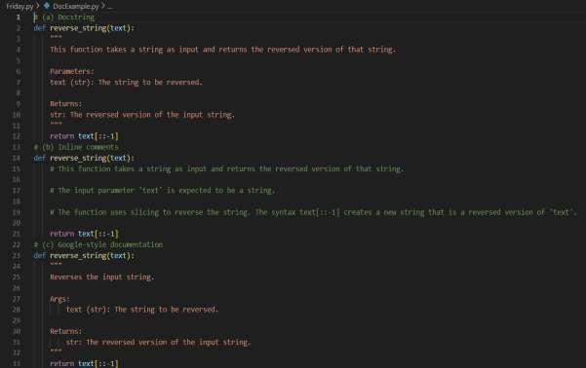
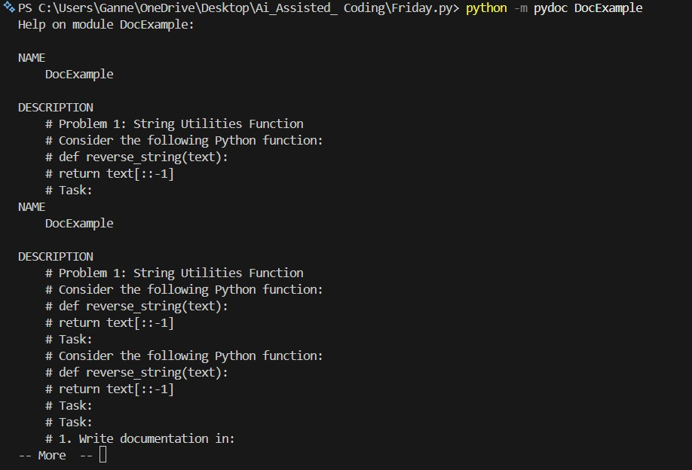

Problem 2: Password Strength Checker
Consider the function: def check_strength(password):
return len(password) >= 8
Task:
- Document the function using docstring, inline comments, and
Google style.
- Compare documentation styles for security-related code.
- Recommend the most appropriate style.

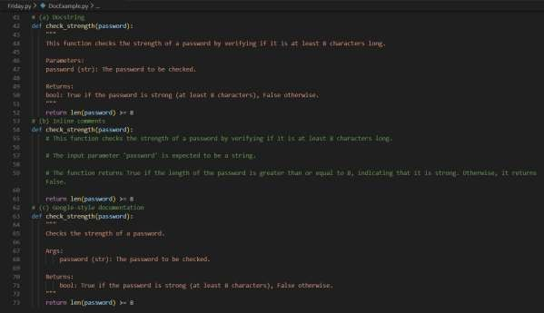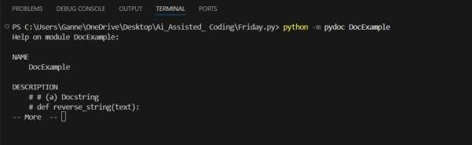

Problem 3: Math Utilities Module
Task:
1. Create a module math_utils.py with functions:
- square(n) o cube(n)
- factorial(n)
- Generate docstrings automatically using AI tools.
- Export documentation as an HTML file.

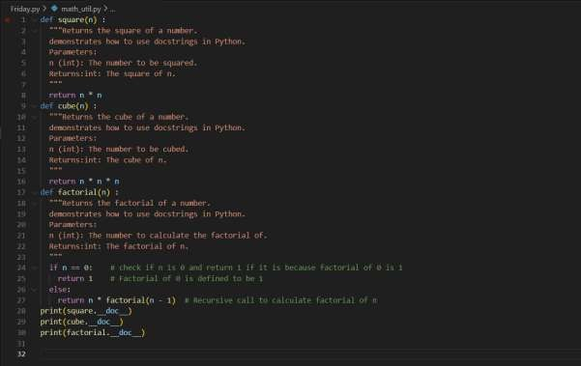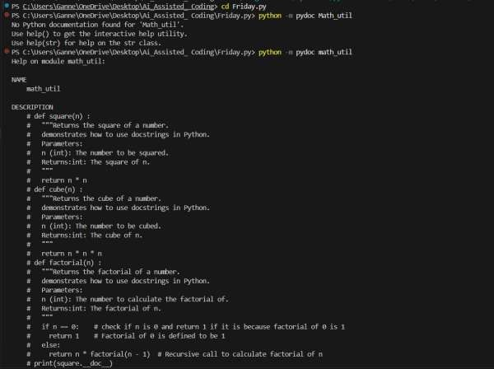

Problem 4: Attendance Management Module
Task:
1. Create a module attendance.py with functions:
o mark_present(student) o mark_absent(student) o get_attendance(student)
- Add proper docstrings.
- Generate and view documentation in terminal and browse
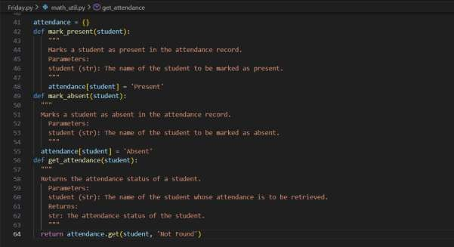
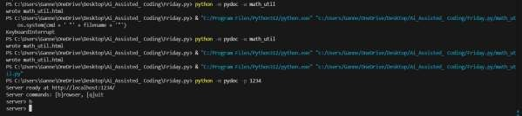
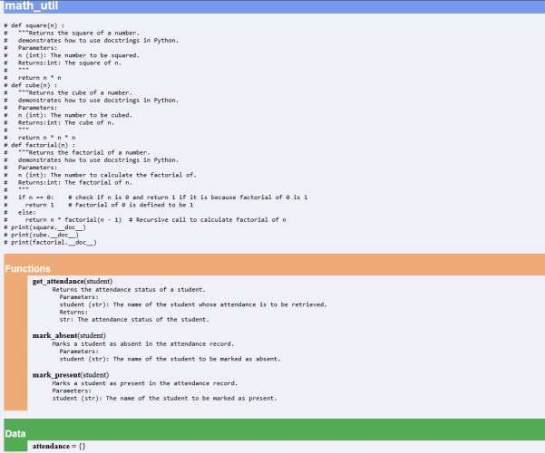

Problem 5: File Handling Function
Consider the function: def read_file(filename):
with open(filename, 'r') as f:
return f.read()
Task:
- Write documentation using all three formats.
- Identify which style best explains exception handling.
- Justify your recommendation.

